**HEALTH PROMOTION AND MAINTENANCE**

* **Health promotion** is the process of enabling people to increase control over, and to improve their health.

**(WHO,1986)**

* Health promotion refers to activities that increase the well-being and enhance wellness or health.

**(Pender, Murdaugh and parsons,2006)**

* It is the process which empowers families and communities to improve their quality of life, achieve and maintain health and wellness. It emphasizes not only prevention of disease, but the promotion of positive good health.

**Health Promotional Activities of middle-aged adult:**

1. Immunization
2. Hormone replacement therapy
3. Safety and accident prevention
4. Screening
5. Counselling
6. Lifestyle changes.
7. Stress management and adaptive mechanism.

**HORMONE REPLACEMENT THERAPY**

**Introduction:**

* Hormone replacement therapy is any form of hormonal therapy of a patient who is in course of medical treatment receives hormone either for supplement of naturally occurring hormones or to substitute other hormone for naturally occurring hormones.
* Common forms of hormone replacement therapy.
* For menopause
* Androgen replacement therapy for male
* Hormone replacement therapy (HRT), also known as menopausal hormone therapy (MHT) or postmenopausal hormone therapy (PHT, PMHT), is a form of hormone therapy used to treat or relieve sweating, hot flashes, and other symptoms associated with female menopause.

**Indication:**

The hormonal replacement therapy (HRT) is indicated in menopausal women to overcome the short-term and long-term consequences of estrogen deficiency.

* To Relief of menopausal symptoms.
* Prevention of osteoporosis.
* To maintain the quality of life in menopausal years.
* Special group of women to whom HRT should be prescribed:
* Premature ovarian failure
* Gonadal dysgenesis
* Surgical or radiation menopause

**Types of Hormone Replacement Therapy:**

**In Women:**

1. **Oestrogen-only HRT:**

* Women who have had a hysterectomy where their uterus, or womb, and ovaries have been removed do not need progesterone.
* Commonly used estrogens are conjugated estrogen [Premarin, Estrocon] or micronized estradiol [Estrebet, Evadiol].

1. **Cyclical or sequential HRT:**

* Women who are still menstruating but have perimenopausal like symptoms can use this.
* Cycles may be monthly, with an oestrogen plus progesterone dose at the end of the menstrual cycle for 14 days, or a daily dose of oestrogen and progesterone for 14 days every 13 weeks.

1. **Continuous HRT:**

* This is used during postmenopausal. The patient takes a continuous combination of oestrogen and progesterone.
* Example: Utrogestan 100 mg daily at bedtime along with separate estrogen.

1. **Local oestrogen:**

* This includes vaginal tablets, creams, or rings. It can help with urogenital problems, including dry vagina and irritations.

**In Men:**

* Men do not go through a well-defined period referred to as menopause, they experience a decline in the production of the male hormone testosterone (androgen) with aging.
* Along with the decline in testosterone, some men experience symptoms that include Fatigue, Weakness, Depression, Sexual problems.

1. **Intramuscular testosterone injections:**

Inject these into the muscles of buttocks every two to three weeks.

Example: testosterone propionate, testosterone enanthate.

1. **Testosterone patches:**

Apply these each day to back, arms, buttocks, or abdomen. Be sure to rotate the application sites.

1. **Topical testosterone gel:**

Apply this each day to shoulders, arms, or abdomen.

* Testosterone is required for:
* male sexual development
* reproductive function
* building muscle bulk
* maintaining healthy levels of red blood cells
* maintaining bone density
* However, the natural decrease of this hormone in men typically doesn’t affect overall health any more than the aging process does.

**Ways of delivering HRT include:**

* intramuscular injection
* creams or gels
* vaginal rings
* tablets
* skin patches

**Side effects of Hormone Replacement Therapy:**

**In Women:**

* Bloating
* Breast tenderness or swelling
* Swelling in other part of the body
* Feeling sick
* Leg cramps.
* Headache
* Indigestion
* Vaginal bleeding

**In Men:**

* breast enlargement
* decreased testicle size.
* worsening of existing sleep apnoea
* increased cholesterol levels
* decreased sperm count.
* Infertility
* increased number of red blood cell

**Long term side effects of HRT:**

* cardiovascular disease
* blood clots (pulmonary embolism, deep vein thrombosis, stroke)
* breast pain and breast cancer
* migraine headache
* mood swings
* hair thinning

**Contraindication of HRT:**

**In Women:**

HRT may not be suitable for women who have a history of:

* Uncontrolled hypertension, or high blood pressure
* Severe migraines
* Thrombosis or blood clots
* Stroke
* Heart disease
* Endometrial, ovarian or breast cancer.

**In Men:**

* Prostate cancer
* Uncontrolled heart failure
* Myocardial infraction or cerebrovascular accident within the past six months
* Haematocrit over 48 %
* Men planning fertility.

**Nursing implication in hormone replacement therapy (HRT):**

1. **Prior to administration:**

* Obtain complete history.
* Family history
* Disease condition
* Drug allergy.

1. **During HRT:**

* Nurses must have current knowledge of hormonal replacement therapy to counsel the patients.
* Monitor for thromboembolic disease and instruct client to report shortness of breath, chest pain feeling of heaviness etc.
* Monitor for abnormal uterine bleeding and instruct client to report excessive bleeding that may occur during menstruation.
* Unscheduled bleeding in first 6 months normal but it persists beyond 6 months, rule out other causes.
* Monitor breast health and educate patient to have regular breast examination.
* Monitor the effectiveness by improvement in symptoms.
* Screening for mammography and cervical smear if not altered, to be continued.

1. **Education:**

* Teach for exercise 30 minutes 5 times per week/ minimum of 3 times per week.
* No smoking
* Maintain a normal blood pressure.
* Maintain a normal weight.
* Eat a healthy diet.
* Remain mentally active.
* Prevent diabetes.

**SCREENING**

**Introduction:**

* Screening is defined as the presumptive identification of unrecognized disease in an apparently healthy, asymptomatic population by means of tests, examinations or other procedures that can be applied rapidly and easily to the target population.
* Adult should be encouraged for different types of screening which is essential for healthy life. For e.g.-Pap smear for cervical cancer, X-ray for T.B, blood pressure for Hypertension etc. In this way, disease or risk factors are being detected earlier allowing either for early treatment or for prevention, including limiting further spread transmission.

**Uses of Screening**

1. **Case Detection (Prescriptive Screening)**

* Defined as “the presumptive identification of unrecognized disease, which doesn’t arise from a patients request.

1. **Control of disease (prospective Screening)**

* People are examined for the benefit of others.
* Screening of immigrants from infectious diseases like Ebola, tb and syphilis to protect the home population.
* Screening for HIV, STD etc.

1. **Research Purpose**

* To know the history of many chronic diseases like Cancer, HTN etc.
* Screening may aid in obtaining more basic knowledge about the natural history of such diseases.

1. **Educational opportunities**

* Screening programs help in:
* Acquisition of information of public health relevance.
* Providing opportunities for creating public awareness.
* For educating health professionals.

**Difference Between Screening Test and Diagnostic Test**

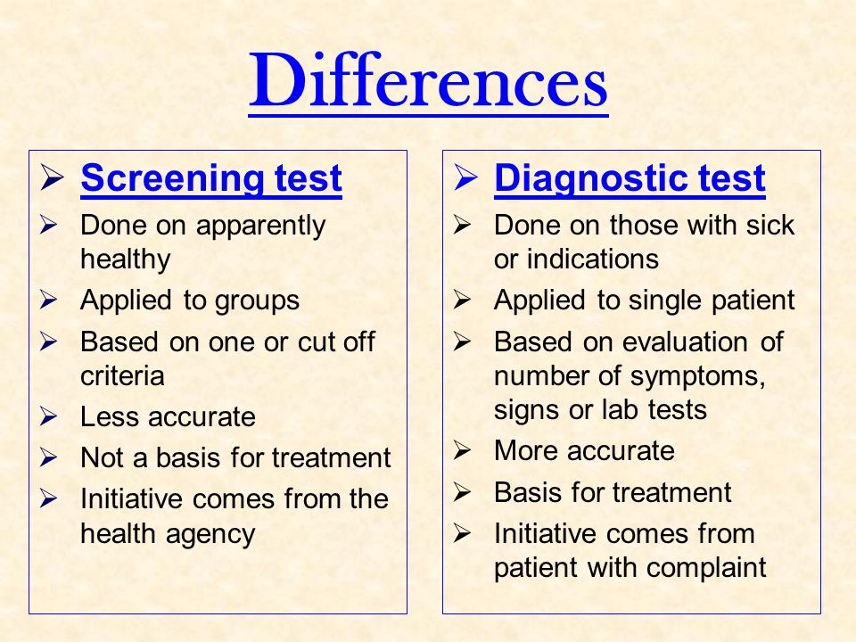

**Types of Screening:**

1. **Mass Screening**

* Mass screening simply means the screening of a whole population or a subgroup. E.g. adults
* Example:
* Mammography in women aged 40 years or less.
* Colonoscopy for occult blood.

1. **High Risk Screening**

* It is applied selectively to high-risk groups, the groups defined based on epidemiological research.
* Example:
* Screening for familiar cancers, HTN and DM
* Screening for cervix cancer in low social group
* Screening for HIV in risk group.

1. **Multi-Phasic Screening**

* It is the application of two or more screening tests in combination to many people at one time than to carry out screening tests for single diseases.
* This Procedure may also include health questionnaire, clinical examination and a range of measurement and investigations.
* Example:
* DM- Fasting Blood sugar, Glucose Tolerance test
* Sickle cell Anemia- Complete blood count, HB, Electrophoresis

1. **Multi-Purpose Screening**

* The screening of population by more than one test done simultaneously to detect more than one disease.
* Example: Screening of a pregnant women for VDRL, HIV, HBV by a serological test.

**Different screening is performed in adult to monitor proper functioning of the body organs. And to detect any abnormal condition are given below:**

1. Blood pressure screening

* **The USPSTF (US Preventive Services Task Force)** suggests annual screening for hypertension in adults 40 years or older and for adults at increased risk for hypertension,
* Every 3 to 5 years, for adults aged 18 to 39 years, not at increased risk for hypertension and with a prior normal blood pressure reading.

1. Cholesterol screening and heart disease prevention

* If patient age is 35 years or older, check cholesterol, electrocardiography every 5 years.
* **National Heart, Lung and Blood Institute** recommends, adults aged 20 to 45 yearsshould be screened every 5 years.
* Men ages 45 to 65 and women ages 55 to 65 should be screened every 1 to 2 years.
* Older adults after 65 years should be screened every year.

1. Diabetes screening

* **American Diabetes Association** recommends testing for prediabetes and risk for future diabetes for all people beginning at age of 45 years.
* If the tests are normal, it is reasonable to repeat testing at minimum of 3 years interval.

1. Kidney Function Test

* Creatinine test at every 2 years of interval is recommended.

1. Osteoporosis screening

* **National Institute of Health** recommend, Bone mineral density (BMD) testing should be performed:
* In women aged 65 and older and men aged 70 and older.
* In postmenopausal women and men above age 50 to 69, based on risk factor profile.
* In postmenopausal women and men aged 50 and older who have had an adult age fracture, to diagnose and determine degree of osteoporosis.

1. Female: Breast, Uterus, and Cervix

* Breast self-examination monthly.
* **U.S. Preventive Services Task Force (USPSTF)** recommended, women at average risk of breast cancer start mammograms at age 40 and have a mammogram every other year.
* Precancers rarely cause symptoms, which is why regular cervical cancer screening is important, even if you have been vaccinated against HPV.
* Co-test (an HPV test with a Pap test) every 5 years or a Pap test every 3 years.
* Women living with HIV should be screened every 3 years starting at age 25.
* The global strategy encourages a minimum of two lifetime screens with a high-performance HPV test by age 35 and again by age 45 years.
* In women who test negative on VIA or cytology (Pap smear), the screening interval for repeat screening should be every three to five years.
* In women who test negative on an HPV test, rescreening should be done after a minimum interval of five years.

1. Male: scrotum, penis, prostate

* Testicular examination monthly.
* Clinical examination if one testicle seems much larger or harder or if a lump is present.
* Prostate examination through digital rectal by professional exam and blood test for prostate-specific antigen (PSA).
* Men aged 55 to 69 years, every 2 to 4 years and rescreening interval may be lengthened or even discontinued for men 75 years or older with PSA < 3 ng/ml.

1. Male and female: Skin

* Self-examination monthly after bath or shower to become familiar with general appearance of skin and pattern of spots, blemishes, color.
* Have someone else check top of head if bald or thin hair, back of neck, buttocks, and thigh.
* Use mirror to complete observation if exam must be done completely by self.

1. Thyroid screening

* **American Thyroid Association** recommends adults should be screened for thyroid dysfunction by measurement of the serum thyrotropin concentration, beginning at age 35 years and every 5 years thereafter.
* This test is recommended to middle adult age adult, pre- menopausal and post -menopausal women.

1. Colon cancer screening

* The **U.S. Preventive Services Task Force** recommends, adults aged 45 to 75 be screened for colorectal cancer.
* Earlier if they have a strong family history of colon cancer or polyps, inflammatory bowel disease.
* There are several screening tests available. Some common screening tests include:
* A stool occult blood test is done every year.
* Flexible sigmoidoscopy every 5 years along with a stool occult blood test every 3 years.
* Colonoscopy every 10 years. Need colonoscopy more often if they have risk factors for colon cancer, such as:
* Ulcerative colitis
* A personal or family history of colorectal cancer.
* A history of colorectal adenomas.

1. Dental examination

* Annual dental examination is recommended to detect and prevent dental carries and periodontal disease.

1. Eye exam

* Have an eye exam every 2-4 years, ageing from 40-54 years and every 1-3 years ageing from 55-64 years.

**LIFE-STYLE CHANGES**

* Lifestyle can be defined as a way of living the things that a person or group of people usually do.
* Adopting a healthy and balanced lifestyle helps young adult to work efficiently and achieve their goal successfully as well as sustain a wellness state throughout the middle adulthood old age.
* Adulthood should be counseled about the positive lifestyle changes needed to adopt and help them to cope with those changes.

**Lifestyle changes in middle adulthood:**

**Physiological changes**

* Wrinkled skin
* Loose elastic skin with loss of skin turgor
* Drier skin due to less production of sebum.
* Loss of hair.
* Decreased in sensory function.
* Menopause in female etc.

**Emotional changes**

* Varying level of estrogen, progesterone and other hormonal changes in middle adulthood affect the mood like irritability, anger due to physical changes, depression, changes in sexual desire may occur.

**Changing in the nutrition pattern**

* BMI decreased along with basal energy requirement due to reduced physical activity and loss in functioning of protoplasm causes less demand for calories.
* Calories should be taken from carbohydrate is 45-60%, from protein is 10-35% and from fat is 20-35%.
* High fiber diet should be provided to prevent constipation.

**Changes in role and responsibilities**

* Middle-aged person is the sandwich generation. They have both responsibilities of children as well as aging parents. side by side they have occupational and familiar and social responsibilities that may lead to physical and psychological exhaustion.

**Rest and Sleep**

* Most of middle-aged person sleep about 7-8 hours without difficulties per day, which must be balanced with physical activity to maintain optimum function. Middle age awakes several times during night in contrast to the young adult and duration of sleep is shorter.

**Sexuality**

* Men need more time to get erection. In male, production of testosterone decreased and in female gradually decrease estrogen and progesterone, wall of the vagina become less elastic, thinner and vagina shrinks causing painful intercourse for some women.

**Nursing Responsibility for lifestyle changes:**

Patient can be educated about the following life-style changes needed to be considered.

* Nutrition – healthy and balanced diet containing items from each of four main categories (carbohydrates, vitamins, fats, and protein) to be taken daily, including folic acid.
* Attaining and maintaining healthy weight for age and sex group (Normal BMI: 18.5-24.9 kg/ m2)
* Getting 7-9 hours of sleep at night every day.
* Avoid or limit the use of caffeinated beverages and alcohol.
* Perform physical exercise at least 30 minutes a day or 150 minutes a week including (stretching/ flexibility, weight bearing/ strength training, balance, and endurance/ cardio exercises).
* Helping smokers quit and promoting smoke-free public places.
* Identifying the predisposing factors and risk behaviors and helping the client to modify or eliminate them.
* Maintaining a healthy and safe sexual life.
* Practicing yoga, meditation, and other recreational activities.
* Drink adequate water to maintained hydration.

**STRESS MANAGEMENT AND ADAPTIVE MECHANISM**

**Stress** is the non-specific response of the body to any demand made upon it.

**Nursing implication in stress management:**

* Identify the possible causes of stress.
* Provide warm and trusting atmosphere/environment.
* Develop good rapport with each other.
* Listen their problems attentively/understand the situation and problem and help to the client to determine situation/facts rather than imagination.
* Encourage to verbalize feelings, perceptions, and fear.
* Provide the client information concerning diagnosis, treatment, and prognosis.
* Appraise the patient's adjustment to his/her body image as needed.
* Approve and discuss alternative responses to the situation.
* Identify his strength and weakness.
* Recognize usual coping mechanism and help to adopt as needed.
* Identify and encourage them to involve in support group.
* Accept love and support from others.
* Stay with the client: to promote safety and feeling of security and to reduce fear.
* Teaching healthy ADLs; Exercise, sleep, and Nutrition
* Recognize usual coping mechanism and help to adopt as needed.
* Set a time of relaxation each day. A special place in home to relax, a special time for doing certain pleasurable activities or a person in confidence and friendly.
* Do one thing at a time.
* Assume more positive attitudes toward irritating and frustrating situations or events.
* Determine to enjoy selected stressors as a challenge: e.g. examination.
* Talk about the feelings with friends and counselors.
* Dealing with stressful situations: The Four ‘A’s
* Change the situation:
* Avoid the stressor.
* Alter the stressor.
* Change your reaction:
* Adapt to the stressor.
* Accept the stressor.
* Encourage to adopt various techniques of stress management e.g. relaxation techniques, meditation etc.

There are variety of ways of coping with stress. Some techniques of time management may help a person to control stress. In the face of high demands, effective stress management involves learning to set limits and to say “No” to some demands that other make. Following technique should be done:

1. **Meditation**

Meditation is a mind-body practice in complementary and alternative medicine (CMA). There are many types of meditation, most of the originated in ancient religious and spiritual traditions. Meditation helps learn to focus attention. This practice is believed to result in a state of greater calmness and physical relaxation, and psychological balance. Practicing meditation can change how a person relates to the flow of emotion and thoughts.

1. **Progressive relaxation**

Progressive muscle relaxation can be practiced while lying on back or sitting in a chair with head supported. Each muscle or muscle group is tensed for five seconds and then relaxed for twenty seconds. This procedure is repeated at least once. At first only partial relaxation may occur, but after practice the whole body can relax within a few minutes. This technique has been effective in the treatment of muscular tension, anxiety, insomnia, depression, fatigue, muscle spasm, neck and back pain, high blood pressure etc.

1. **Autogenic training**

Autogenic training is a relaxation technique developed by the German psychiatrist Johannes Heinrich Schultz and first published in 1932. The sessions that last around 25 minutes, usually in the morning, at launch time, and in the evening. Each session can be practiced in a position chosen amongst a set of recommended postures (for example, lying down sitting like a rag doll). The technique can be used to alleviate many stresses induced psychosomatic disorders.